/ 55

%
Structures & Materials Test

NB Qs in RED are the old syllabus – do not attempt.

1 Some solid letters for a shop sign are made of wood. Write the order of increasing stability of the letters PLIT in the boxes below them (least stable = 1, most stable = 4) [2 marks]

A
B
C
D
2. A stone cathedral roof is made of 4 stone sections as shown. Draw arrows to show the directions of the forces at each end of sections A, B, C, D [2 marks]


Spring
3. A man of mass 75.0 kg sits down onto a chair whose seat is spring-loaded. The normal length of the spring is 38.5 cm and with the man sitting on the chair the spring length reduces to 15.7 cm.
Calculate a value for the spring constant of the spring.
[2 marks]

4. A rod made of material X is 0.255 m long and has a circular cross-section with a diameter of 1.20 mm. A variable tensile force was exerted on it and the extension of the rod measured for each force applied. The graph shows the extensions produced as the force was increased, until the material broke.
0.0
0.2
0.4
0.6
0.8
1.0
1.2
1.4
1.6
1.8
2.0
0.2
0.4
0.6
0.8
1.0
1.2
1.4
0.0
Extension (mm)
Force (kN)
Rod

a) Draw a line of best fit and use the graph to calculate the Young’s Modulus of material X. [4 marks]

- (i) Which of the following materials; metal, glass or rubber, is material X most
likely to be? _______________________________ [1 mark]

(ii) Explain your answer to part (i). [2 marks]

- Calculate the tensile strength (breaking stress) of material X from the graph. [2 marks]

- Another rod, made of material Y, has the same size, but has a value for Young’s Modulus of 3.00 x 10¹¹Pa. Y is brittle and has a tensile strength (breaking stress) of 8.8 x 10⁸ Pa.
On the graph above, sketch an approximate line that shows the force-extension relationship for material Y when it is loaded with the same forces.
Show your working for this here. [5 marks]

5. As part of a sculpture two steel cables attached to the ceiling of a museum are used to support a Byzantine figure of mass 1 tonne.
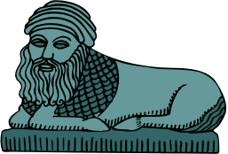
55º
35º
Byzantine Figure (1.00 tonne)
10.00 m
16.38 m
These are the lengths of the cables before the figure is attached.

- Calculate the tensile forces in each of the angled cables holding the figure. [5 marks]

- The cables are made of steel with a diameter of 5.00 mm.
Calculate how much the 10-metre cable stretches when the Byzantine figure is held in position as shown [5 marks]


A
B
65º
25º
C
Strut
Strut
Beam
- A carpenter of mass 90.0 kg stands on the apex (top) of a triangular wooden roof truss. The two struts, AB and AC, are made of thin pinewood and their masses can be ignored.

- State whether the forces in the struts and beam are
compressive or tensile. [3 marks]

Force in strut AB is _____________________

Force in beam BC is _____________________

Force in strut CD is _____________________

- Calculate the force in each strut AB and AC. [4 marks]

- Calculate the force exerted by beam BC to stop the struts moving. [2 marks]

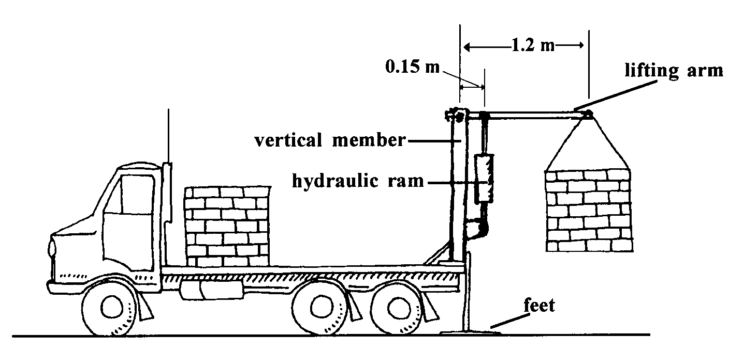
Hydraulic
ram
7.

When small quantities of bricks are delivered the truck driver unloads them using a lifting arm operated with a hydraulic ram as shown in the diagram. A pack of bricks on the truck is attached to the lifting arm and lifted until the arm is in the horizontal position. The arm can then be rotated and the bricks lowered to the ground.

a) Before operating the device, the driver lowers two feet attached to the rear of the truck. Explain why these may be necessary. [2 marks]

b) Calculate the force exerted by the hydraulic ram when holding a pack of bricks, with a mass of 1000kg, in the horizontal position. Ignore the mass of the lifting arm and assume that the hydraulic ram acts vertically. [3 marks]

c) Will the vertical member be under compression or under tension? Explain your answer.
[2 marks]

8. Boom cranes are used on ships to lift cargo up from the inside of the ship. The diagram shows a boom crane where the boom has a length of 4.00 m and a mass of 45.0 kg. The crane holds a load of coal of total weight 2000 N. The boom has a cable attached 3.20 m from its lower pivot (P).
P
50º
3.2 m
2000 N
Boom
4.0 m

The cable is pulled downwards over a pulley by an electric winch until the top cable is horizontal.

- Calculate the tension in the top cable. [4 marks]

- Calculate the size and direction of the reaction force at the pivot. [5 marks]

Solutions

2

1. Stability order is: P 1, L 4, I 3, I 2

2.
A
B
C
D




2

2


3. k = F/x = 75 x 9.8/(0.385 – 0.157) = 3.22 x 10³ Nm⁻¹

4. a)
0.0
0.2
0.4
0.6
0.8
1.0
1.2
1.4
1.6
1.8
2.0
0.2
0.4
0.6
0.8
1.0
1.2
1.4
0.0
Extension (mm)
Force (kN)



Area = π(0.6 x 10⁻³)² = 1.131 x 10⁻⁶ m²
Taking point shown on the line:



4


b) (i) Line shows it is a metal


3
(ii) Graph is linear with a plastic region. Glass has no plastic region and rubber is not linear.

c) Breaking point comes at a force of 0.8 x 10³ = 800 N

2
Stress = F/A = 800/1.131 x 10⁻⁶ = 7.07 x 10⁸ Pa


d) Material Y: point of the force axis is given by 8.8 x 10⁸ = F_{Y}/1.131 x 10⁻⁶ So F_{Y} = 995 N
Material Y is brittle so the line will finish at a point where the force is 995 N
To find the value of extension at this force




5
So the Y line goes through the point (0.75 mm, 995 N) Drawing

5. a) Draw a vector triangle with downward resultant = 9800 N
T₁
T₂
9800 N
35⁰
55⁰
90⁰


T₁ = 9800cos55 = 5.62 x 10³ N



5
T₂ = 9800cos35 = 8.03 x 10³ N


b) For the 10 m cable F = 8.03 x 10³ N, A = π(2.5 x 10³)² = 1.96 x 10⁻⁵ m²




5


6. a) AB compressive

3
BC tension

CA compressive
b)
F_{AC}
F_{AB}
882 N
F_{AC}

F_{AB}

882

Vector triangle




F_{AC} = 882cos65 = 373 N

4
F_{AB} = 882cos25 = 799 N

c) Strut BC


2
Inward components of force F_{AB} and F_{AC} = F_{AB} cos 65 (or F_{AC} cos25) = 338 N

- a) With the bricks in the position shown in the diagram their clockwise torque could cause the

truck to pivot about the back wheel.
When the feet are down the pivot is shifted further to the right. This means that a greater clockwise torque is required to tip the truck.
0.15
1.2
9800
F
2


b) Torques about the pivot:
ΣACT = ΣCT


1.2 x 9800 = 0.15F
3

F = 7.84 x 10⁴ N

c) It is under tension.
Taking torques about the pivot:
9800 N acts clockwise
So the force in the vertical member must be downwards
A force downwards means it is under tension.
2

8. a) Torques about point P ΣACT = ΣCT
P
50º
3.2 m
4.0 m
2000 N
T
441 N


(2cos50 x 441) + (4cos50 x 2000) = 3.2sin50F

5709 = 2.451F

4
F = 2.33 x 10³ N

b) Reaction force
Σ vertical forces = 2441 down
2441
2328
R
θ

Σ horizontal forces 2328 left
To find the net reaction force the vector triangle

must add 2441 up and 2328 right.


R² = 2441² + 2328²

R = 3.37 x 10³ N

Tan θ = 2441/2318

4
θ = 46.5º

